Physics 30 Lesson 27

Rutherford’s Model of the Atom

Thomson’s model of the atom
Refer to Pearson pages 766 to 770 for a discussion of Rutherford’s scattering experiment.

John Dalton had designed a model using the atom as the smallest possible particle. That model was now shown to be incorrect thanks to the work of Thomson, Millikan, Goldstein and others. However, it is interesting to note that for the majority of the chemistry done at the high school level the Dalton model of the atom provides an acceptable way to visualize what is happening in chemical reactions.

Dalton had thought of atoms as indivisible particles, but Thomson’s discovery of electrons indicated that atoms were themselves made of smaller particles called subatomic particles. In 1904, Thomson proposed a model of the atom that was based on the existence of subatomic particles. Thomson’s model of the atom indicated that the atom was a sphere of positive charge and inside the positive sphere was an equal amount of negative charge distributed in the form of electrons. Thus the atom was neutral overall. He used the idea of raisins embedded inside a large bun as an analogy to the structure he imagined. The raisins would represent the negative electrons and the bun would represent the positive sphere.

• •

• •

Thomson’s model gave life to a large number of designs that would allow the electrons to exist within the positive. The elaborate designs allowed for the known principles of electrostatics to be explained. Electrons could be rubbed off or added to the atoms depending on the circumstances. Thomson argued that the chemical properties of the element might be associated with particular groupings of the electrons.

The gold foil experiment
Ernest Rutherford (1871-1937) was a graduate student under J.J. Thomson and thus was strongly influenced by Thomson’s work. In 1910, Rutherford spent a year lecturing at McGill University in Montreal. In 1911, he returned to England to work at Manchester University. In the same year, he began a series of experiments to verify the atomic model proposed by Thomson. The experiments are known as the Gold Foil Scattering Experiments and they would have a tremendous influence on all atomic models from that point on.

In the experiment, gold foil was used because it could be pounded down to a layer only a few atoms thick. Alpha particles (helium ions) from a radioactive radium source were fired at the gold foil. Behind the gold foil was a zinc sulfide screen. Any particle hitting the zinc sulfide caused a glow of light which Rutherford could observe.
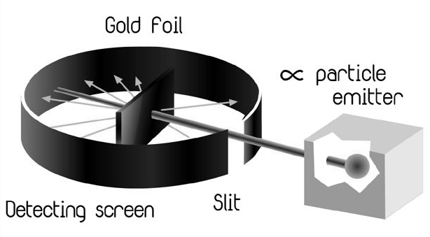

When the apparatus was assembled, Hans Geiger (one of Rutherford’s graduate students) was asked to plot the location of the collisions with the zinc sulfide screen. Geiger would later invent an apparatus to do a better job of detecting charged particles – the Geiger counter.
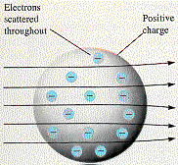
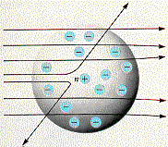
According to the Thomson model of the atom, no appreciable deflection of the α particles should occur. Most of the α particles were expected to travel straight through and only those passing near an electron (raisin) would be slightly deflected due to the electrostatic force of attraction between the positive α particle and the negative electron. Only 1 of 8000 α particles would be slightly deflected when coming close to an electron.

The results, however, were not supportive of Thomson’s model. The majority went straight through the gold foil, but many α particles, not just 1 in 8000, were deflected at slight angles. A completely unexpected result was that some were deflected at large angles (around 90°). Rutherford asked Geiger to extend the zinc sulfide screen around in front of the apparatus to see if any alpha particles were deflected back towards the generator. Geiger found some particles were deflected straight back towards the generator. Rutherford commented, “The result is as incredible as if you fire a 15 inch shell from a battleship at a strip of tissue paper and it reflects back at you.” The Thomson model could not account for this result.

Ernest Rutherford’s nuclear atom
Rutherford now proposed a model of the atom to try to account for the surprising results. He proposed a nuclear atom, one in which most of the mass and all of the positive charge was concentrated in the center of the atom. Alpha particles approaching the 76 proton nucleus of a gold atom would be deflected, sometimes at large angles, by the electrostatic repulsion between the positive charges. The rest of the atom was essentially empty space except for a few electrons. Thus most alpha particles would pass right through this electron cloud.

From the angle of deflection, Rutherford began to calculate the net charge on the nucleus and found it to be very near the value proposed by Moseley (the Z number or the atomic number). Rutherford was also able to determine that the nucleus of an atom made up only 1/1000 000 000 000 of the size or volume of an atom – the atom was essentially empty space. However the vast majority of the atom’s mass (99.98%), as well as all of the positive charge, were concentrated in the nucleus. Like a mini-solar system, the negative electrons orbited around the positive nucleus.

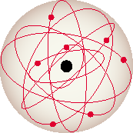
Rutherford’s nuclear atom became the foundational idea for all future models of the atom. Rutherford eventually replaced his mentor as head of the Cavendish labs. He was knighted and eventually received the Nobel Prize for his outstanding discovery. The study of the atom broke, more or less, into two disciplines: Atomic physics – the study of the electron structure around the nucleus (Lessons 25 to 33) and Nuclear physics – the study of the particles within the nucleus (Lessons 35 to 38).

Questions not explained by the Rutherford model
Although Rutherford’s model was easy to visualize and understand, it had some serious flaws:

- Did all of the electrons travel in the same orbit? If they did, why did they not bump into one another? What was the structure of the orbiting electrons?
- From the known bonding characteristics of different chemical compounds, how are the electrons involved in the bonding process?
- Why do the positive protons stay together in the nucleus? Their strong mutual repulsion should tear the nucleus apart.
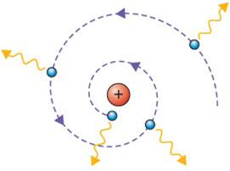
- The final, and most important flaw, concerned the nature of accelerating charges. James Maxwell had shown that accelerating electric charges radiate EM radiation (Lesson 24). If the electrons were in circular orbits, they would continually experience a centripetal acceleration. Thus they should continually radiate energy in the form of light waves. Further, since their kinetic energy is being converted into radiant energy, the electrons should spiral into the nucleus. We know that atoms have stable structures for long periods of time. Something was wrong with Rutherford’s explanation.

Hand-in assignment
1. What kind of particle is given off by the radioactive source in Rutherford’s experiment?

2. Identify the target of the particle beam.

3. What particles make up the sheet of gold foil?

4. Describe what happens when alpha particles strike the gold foil.

5. What happens to particles that approach a gold nucleus head-on? Do these particles collide with the nucleus?

6. What is the purpose of the circular zinc sulfide screen?

7. Why do most alpha particles pass through the gold foil undeflected?

8. What happens to particles that are undeflected?

9. Why are some particles only slightly deflected?

10. Where is the positive charge in an atom? Where is most of the mass found in an atom?

11. Using a diagram, in point form describe Rutherford’s model of the atom.

12. Describe the strengths and weaknesses of Rutherford’s model of the atom.

